A+ Computer Science DODGING ENEMIES

Lab Goal : This lab was designed to teach you how to use lists, loops and ifs.
Files Needed ::
Enemies.java
Enemy.java
Game.java

Lab Description : Write a program that uses lists to keep track of enemies on the screen.

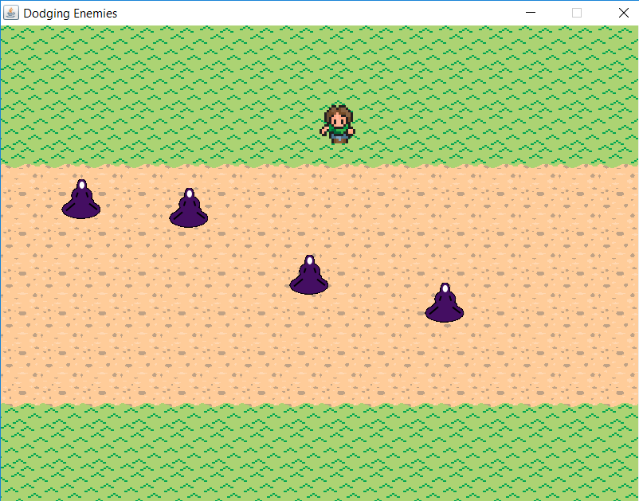
Part One :: In the drawAndCollision() method of enemies.java, go through the list of enemies. For each enemy, call it’s move() and draw(Graphics2D g) methods.

Part Two :: In the drawAndCollision() method, use the guy’s collide() method to determine if any of the enemies collide with guy. Return True if any enemies do.

Part Three :: In the drawAndCollision() method, if an enemy has gone off the screen, remove it from the list of enemies.

Part Four :: In the addEnemy() method, create a new enemy and add it to the list of enemies. The enemy constructor is Enemy(x,y,speed)

In the numEnemies() method, return the length of the list of enemies.

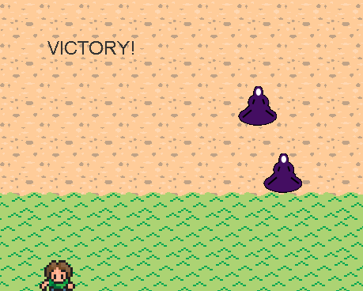
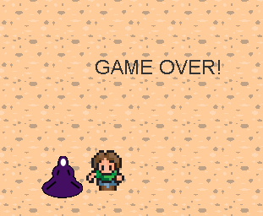
Part FIVE :: If the player reaches the bottom half of the grass call the victory() method if they collide with an enemy call the gameover() method

